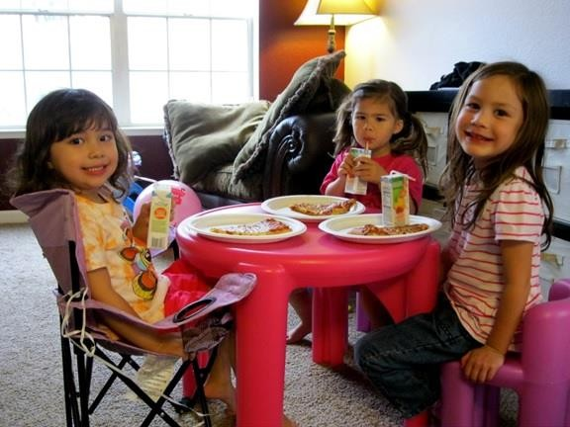

Play Date
I am having a play date.

A play date means that my friend [Friend’s name] is coming over to my house to play with me!

Play dates are so
much fun!
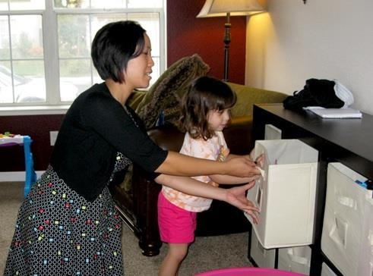It is okay to be a little worried about the play date.

My mom or dad will help me get ready.

I can put some of my favorite toys in a safe place if I am worried about them breaking or being played with.
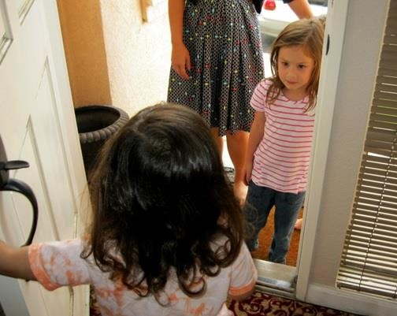When my friend arrives I can meet him/her at
the door and say “hi”.
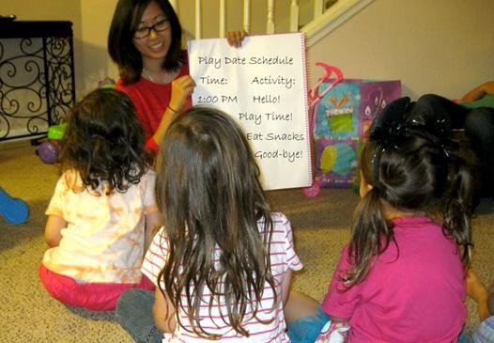First, my mom or dad will go over the schedule with us.

It is a good idea to have a schedule so I know what we will be doing.

I can play and have fun!
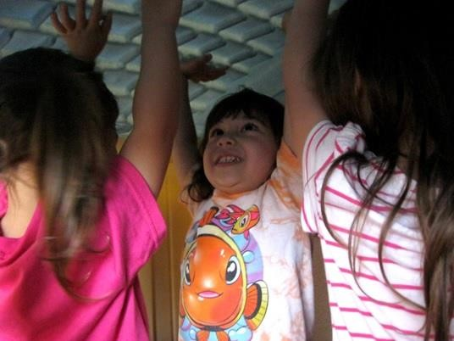When [Friend’s name] is at my house, s/he will have an idea about how s/he wants to play with things.

S/he might say or do things in a way that is different from what I am used to in my house. This is okay.

I can use my words to say if I want to play a certain way or to ask him/her to stop.
I should be flexible when [Friend’s name] is
over at my house.

It takes a lot of courage to play at someone’s house and a lot of courage to have a friend over to play.
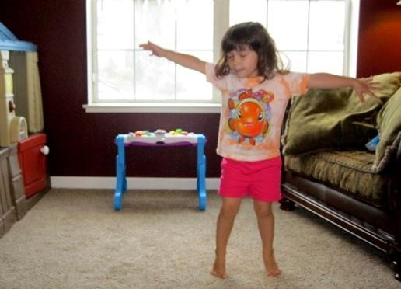If I get frustrated by something [Friend’s name] is doing, I can take a deep breath and go tell mom/dad that I need a break.

After my break we can do something else.

Play dates are so
much fun!
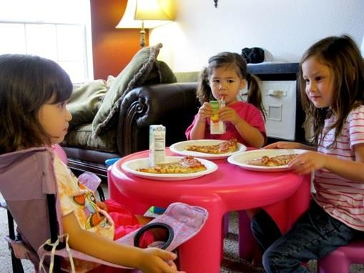During our play date we will have a snack together.

I should ask questions about what s/he likes and we can take turns talking about what our favorite things are.
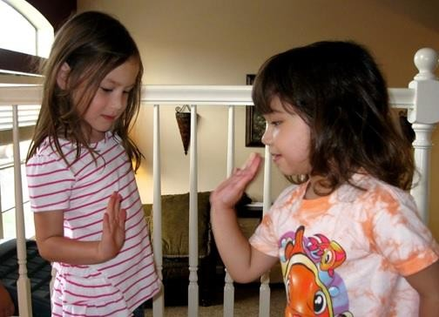After the play date, [Friend’s name] will go home. When s/he goes home, I can say “thank you for playing” and ask to have another play date soon.

I can give [Friend’s name] a high five or a hug if it is okay with him/her.
It is fun to play with my friends and have play dates!

Things to Try

Create a schedule:

Time Event
1:00 My friend arrives
2:00 We have a snack
4:00 My friend goes home. We had fun.

